**ChickHen – Attaching Documents**

To upload a new attachment (on a Flock, Checklist Step, or Template Step) click the upload button next to the blank line in the attachments tab. A popup will appear.

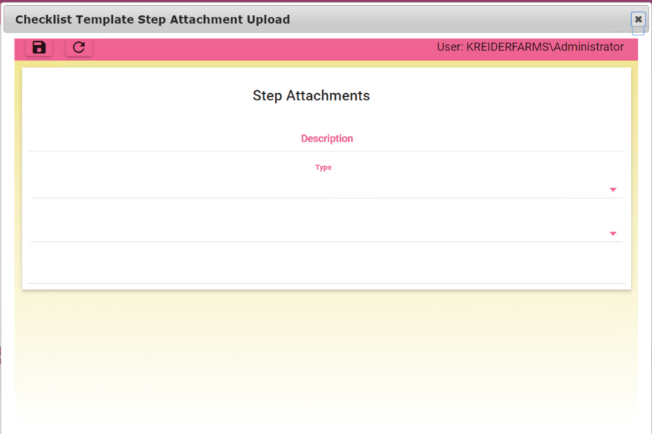

Enter a description and select an Attachment Type (if desired).

You then have ~~two~~ one choice on how to attach a document to the Flock/Step/Template Step.

1. **~~Uploading a not-already-in-soonr document from your PC~~ (removed as an option)**

* ~~Select “Upload from PC” and a few other objects will appear on the screen.~~

~~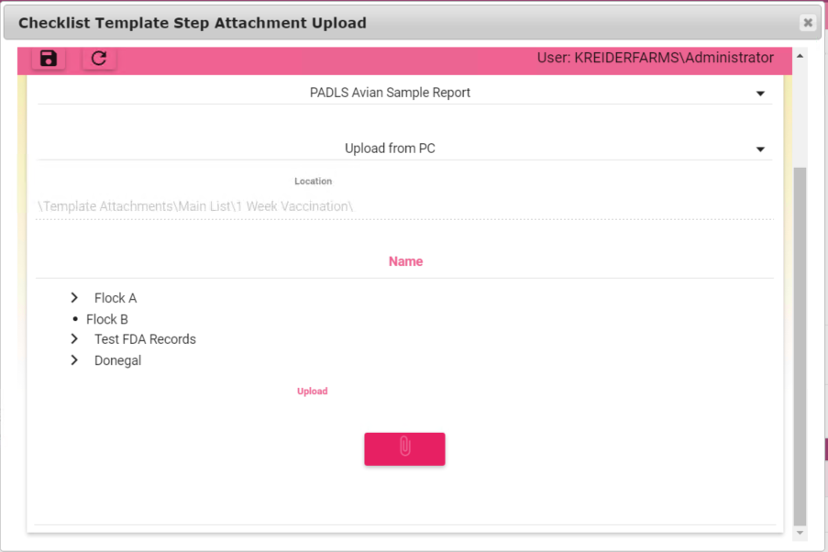~~

~~Location: This is where the file will get uploaded to in soonr. It is shown on the screen for verification purposes only~~

~~Name: This is the name the file will get saved as. It defaults to the name of the file you select, but can be overridden before you upload the file~~

~~Folder Tree: This is a list of all the folders in soonr.~~ *~~Only use this if the default location is not where you want to put the file~~*~~.~~

* ~~Click the Paperclip Icon to bring up your desktop~~
* ~~Select a file~~

~~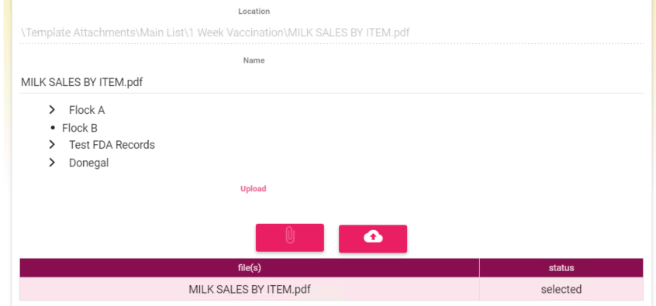~~

~~The name will change to the name of the file. The “Name” field is what the file will get saved as. The name under “file(s)” is what the file is called on your PC.~~

* ~~If desired, change the file name or location~~
  + ~~If you change the Attachment Type after you change the location, it will reset back to the default location.~~
* ~~Click the upload button to save the file and close the popup~~

1. **Choose an Existing File that has already been uploaded to Soonr (whether through Soonr online, the desktop agent, or ChickHen)**

* ~~Select “Select Existing from Soonr”~~



Location: This is where the file will get uploaded to in soonr. It is shown on the screen for verification purposes only

Name: This is the name the file you select. It is not editable.

Folder Tree: This is a list of all the files in soonr.

* Using the file tree, find the file you wish to attach and select it
  + You cannot select folders
  + Gray file names are files that are already attached somewhere else
  + You can attach a file to multiple things without duplicating the file (ex you want the same blank form on 3 different steps). The gray is just to make it easier to find new files- it will not prevent you from selecting a file

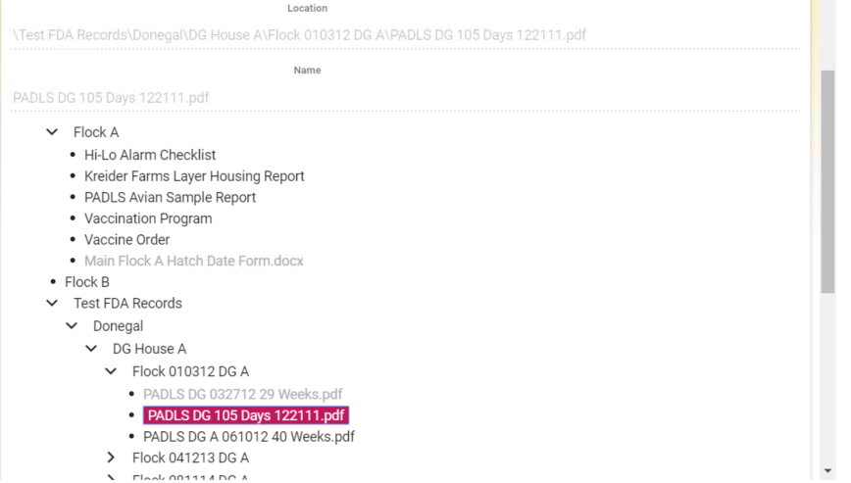

* Click the Save Icon at the top of the popup

**Integration With Soonr**

* A script runs every 2 minutes that looks in Soonr and adds any files or folders to the file tree in ChickHen
  + This script does not handle renaming or deleting objects from Soonr. Any deleted or renamed objects will be broken from ChickHen
  + To delete an object, use the “delete” button on an attachment to delete it from ChickHen (it does not delete the file, just the reference in ChickHen). Then go into Soonr and delete the file
  + To rename an object, use the “delete” button on an attachment to delete it from ChickHen. Rename the file in Soonr, then reattach it in ChickHen using the “Select existing from Soonr” option
* ~~All files uploaded into ChickHen will automatically be synced with Soonr, as soon as the upload and sync are complete (immediate)~~